ONG JIA AUN WEA150022

1. Identify 4 areas where neural network can be applied to solve problems. [4 marks]

- Pattern Recognition (Image, character)

- Spam filtering

- Forecasting

- Medical Diagnosis

2. Why do we need Multi-Layer Perceptron (MLP) in addition to the Perceptron? Illustrate your explanation using a case. [4 marks]

- Single-layer perceptron can only solve linearly separable classification

- Case in point, single-layer perceptron cannot solve XOR logic gate problem

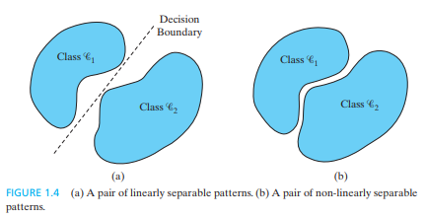

- With Multi-Layer perceptron, XOR logic gate problem can be solve.

- MLP can solve any given function.

3. Describe a challenge with regard to learning rate selection in backpropagation training. [2 marks]

- If learning rate is high, it may oscillate around global minimum

- If learning rate is low, it may get stuck at the local minimum, not having enough energy to leave the pit, thus never reaching the global minimum.